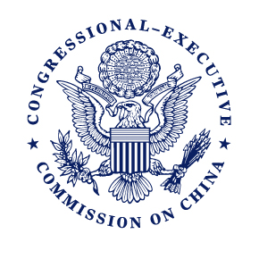
Statement of U.S. Senator Marco Rubio, Cochairman of the Congressional-Executive Commission on China (CECC)
CECC Hearing on “Urging China’s President to Stop State-Sponsored Human Rights Abuses”
Friday, September 18, 2015

As prepared for delivery.
Events in China have garnered significant media attention in recent months. From wildly fluctuating markets which have directly impacted American businesses and families, to unprecedented cyberattacks on government networks which compromised the personal data of millions of Americans—China is in the news.
These issues, along with China’s continued aggression in the South China Sea will most assuredly be on the agenda during the upcoming State Visit of Chinese President and Communist Party General Secretary Xi Jinping next week. Whether the Obama administration will be able to secure meaningful progress on any of these fronts remains to be seen, although if previous rounds of cordial dialogue are any indication, the prospects are bleak.
In addition to these myriad issues is China’s grave and deteriorating human rights landscape—a particularly intractable area in our bilateral relations, and one which has worsened significantly on this administration’s watch.
The past year alone has been marked by further erosion of rule of law, tightening restrictions on civil society and outright attacks on human rights defenders and political dissidents. In its forthcoming annual report the Congressional-Executive Commission on China will document efforts to muzzle dissent and suppress human rights advocacy that are broader in scope than any other period since the Commission started issuing Annual Reports in 2002.
We’ve seen human rights lawyers disappeared, churches demolished and crosses torn down and Tibetan Buddhist monks setting themselves aflame in desperation at the oppression experienced by their people.
These are realities in Xi Jinping’s China.
While President Xi is greeted with a 21-gun salute, a prominent human rights lawyer is unaccounted for, his whereabouts unknown after being taken into custody by the Public Security Bureau. While President Xi is wined and dined in the White House, a Nobel Peace Prize Laureate languishes in prison.
The CECC is featuring stories like these, and many others, through the “Free China’s Heroes” initiative in the days leading up to Xi’s visit. We are profiling the cases of individual prisoners of conscience in an effort to put a human face on the suffering that has accompanied Xi Jinping’s ascent to power.
Too often the Obama administration wants credit for “raising human rights”—but passing mentions and diminished significance in the broader bilateral agenda provides little solace to the brave men and women who face unimaginable obstacles and hardship for daring to claim their most basic human rights.
At the very least President Obama should meet with U.S.-based Chinese dissidents and activists before the state visit—even invite several of them to attend the state dinner.
They represent the future of China. They are writers and lawyers. They are activists and students. They have democratic aspirations and dreams for their country that do not include harassment, abuse and imprisonment.
It’s time for America to get back on the right side of history—to stand with the oppressed not the oppressor.

