Disaster News
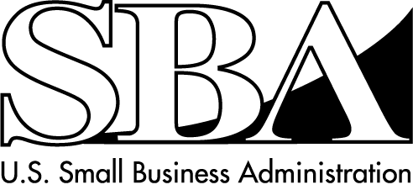
Loans for Homeowners, Renters and Businesses of All Sizes
SBA Disaster Assistance – Field Operations Center- East – 101 Marietta Street, NW, Suite 700, Atlanta, GA 30303

Release Date: November 3, 2012 Contact: Michael Lampton
Release Number: 13-054, NJ 13367/13368 Phone: 404-331-0333

SBA Opens Business Recovery Center in Manahawkin, NJ

ATLANTA –The U.S. Small Business Administration announced today the opening of a Business Recovery Center in Manahawkin, NJ. This Center will provide one-on-one help to business owners seeking disaster assistance for losses caused by Hurricane Sandy that began on Oct. 26.

“Businesses with physical damages or loss of revenue should seriously consider visiting the Center and applying for an SBA disaster business loan,” said Alfred Titone, SBA’s
New Jersey district director. SBA’s customer service representatives are on hand at the Center to answer questions about the disaster loan program and assist business owners in completing their applications.

The Center opens as indicated below:

Ocean County
Southern Ocean County Chamber of Commerce
Stafford Heritage Park Train Station and Rail Car
(Across from Manahawkin Lake between RT 9 and RT 72)
West Bay Avenue
Manahawkin, NJ 08050

Opens: Tuesday, Nov. 6 at 10 a.m.
Hours: Monday – Sunday from 10 a.m. to 6 p.m., until further notice

Businesses and non-profit organizations of any size may borrow up to $2 million to repair or replace damaged or destroyed real estate, machinery and equipment, inventory, and other business assets.
The SBA may increase a loan up to 20 percent of the total amount of disaster damage to real estate and/or leasehold improvements, as verified by SBA, to make improvements that lessen the risk of property damage by future disasters of the same kind.

-more-

For small businesses, small agricultural cooperatives, small businesses engaged in aquaculture, and most private non-profit organizations, the SBA offers Economic Injury Disaster Loans to help meet working capital needs caused by the disaster. Economic Injury Disaster Loan assistance is available regardless of whether the business suffered any physical property damage.

Interest rates are as low as 3 percent for non-profit organizations and 4 percent for businesses with terms up to 30 years. Loan amounts and terms are set by the SBA and are based on each applicant’s financial condition.

Applicants may apply online using the Electronic Loan Application (ELA) via SBA’s secure website at https://disasterloan.sba.gov/ela.

Individuals and business owners who sustained losses in the designated counties in New Jersey can apply for assistance by calling 1-800-621-FEMA (3362). Disaster assistance applicants, who have a speech disability or hearing loss and use TTY, should call 1-800-462-7585 directly; for those who use 711 or Video Relay Service (VRS), call 1-800-621-3362. The toll-free telephone numbers will operate from 7 a.m. to 10 p.m. (local time) seven days a week until further notice. Those in affected areas with access to the internet may register by web enabled mobile device at m.fema.gov, or online at www.disasterassistance.gov.

Additional details on the locations of Disaster Recovery Centers and the loan application process can be obtained by calling the SBA Customer Service Center at 800-659-2955 (800-877-8339 for the deaf and hard-of-hearing) or by sending an email to disastercustomerservice@sba.gov. Loan applications can be downloaded from www.sba.gov. Completed applications should be mailed to: U.S. Small Business Administration, Processing and Disbursement Center, 14925 Kingsport Road, Fort Worth, TX 76155.

The filing deadline to return applications for physical property damage is December 31, 2012. The deadline to return economic injury applications is July 31, 2013.

# # #

For more information about the SBA’s Disaster Loan Program, visit our website at www.sba.gov.

