

2,175 Stolen Children and the ‘Child Bride City’ of Putian
Exposing China’s Massive Trafficking Problem

Chai Ling, Founder of All Girls Allowed, June 13th, 2011
House Committee on Foreign Affairs
Subcommittee on Africa, Global Health, and Human Rights

Introduction: The One-Child Policy and the Child Bride Market
There has never been a more dangerous time to be a child in China. The One-Child Policy and a cultural preference for sons has led to the elimination of millions of China’s girls, which in turn has created an influx of young men and an increased demand for brides. What has emerged is a black market of stolen children unlike anything the world has ever seen, leaving Chinese families fearful every day for the safety of their children.

There are 37 million more men than women in China. Many of these ‘bare branches’ will never wed, settle down, and create their own families. Because of this, some Chinese families are willing to go to desperate measures to ensure that their sons will marry. Even with the costs of rearing a child, purchasing a child bride is the most economical way to guarantee that a son may wed when he is older. The cost of purchasing and raising a child bride is less than ten percent of the cost of a traditional wedding.

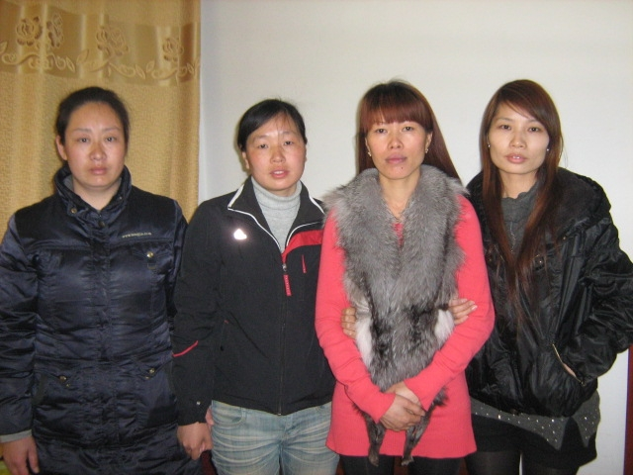
This practice is not an age-old cultural tradition that should be respected. It is the kidnapping and selling of toddler girls to be raised as slaves. It is a recent, tragic consequence of the One-Child Policy and extreme poverty. Today in China, 550 children are stolen every day, usually from poor families unable to afford childcare—that’s 200,000 children a year. In comparison, the U.S. sees 115 kidnappings per year. We can expect this problem to get much worse as the gender imbalance increases.

In this statement, we are making a case for the following four requests:

- That China would focus on finding 2,175 children: http://www.zgfq.org/cr.aspx .
Each of these women is looking to be reunited with her family.

- That China would focus on regions known for trafficking problems, especially Fujian Province.
- That China would spend money and resources to help parents who are searching for their children in a way that is effective, respectful, and encouraging.
- That China would create a system similar to the U.S.’s Amber Alert system to immediately begin the search and rescue processthe moment a child disappears.
All Girls Allowed
All Girls Allowed exists to restore life, value, and dignity to girls and mothers and to reveal the injustices of the One-Child Policy. Our AGA team is inspired by our love for Jesus and our desire to follow Him, as we are commanded to act justly, love mercy and walk humbly with our God. We work in places in China that have the greatest need in order to counter the many negative effects of the policy, such as the infanticide of baby girls, the selective abortion of girls, abandonment, and trafficking. Many of our anti-trafficking workers are parents who have lost their own sons or daughters to kidnapping. These volunteers use two primary methods to create change on a large scale, and to touch hearts on a personal scale, for thousands of families: (1) Research and (2) Rescue Campaigning.

Method 1: Research
When discussing the best practices for combating trafficking, the very first item is research. From research, all other strategies and systems may emerge. Our workers spent months examining one hotbed area for trafficking in China through surveys, demographic research, and other investigative methods. They created a seven-page report on the city of Putian in Fujian Province, where potentially hundreds of thousands of child brides live trapped, waiting to be wed, or already bound inside of a forced marriage.
The root causes of trafficking must be understood before real progress can be made in ending the problem. Combating trafficking includes both rescue and prevention. Attached to the end of this statement is an abbreviated report on child bride trafficking in the city of Putian. Included in this report are the root causes of trafficking specific to Fujian Province and personal stories, statistics, and information about rescue campaigns. This report provides a good example of documentation that can act as a basis to work from when tackling such a massive problem.

Method 2: Rescue Campaigns
The second method AGA uses in the battle against trafficking in China is rescue campaigning.

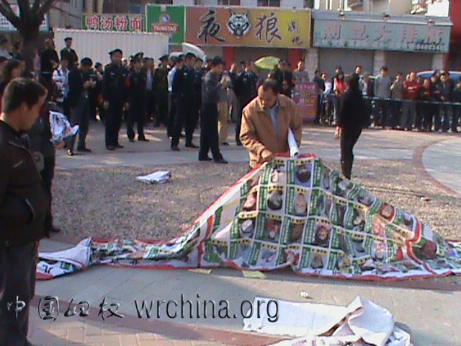
After compiling names, photos, and other information for 2,175 children who are currently missing in China, rescue workers printed large banners and pamphlets that can be carried from village to village in extensive rescue campaigns. They created an online database of profiles, as well as a rescue hotline for tips about the missing children.
The volunteers regularly campaign throughout the country with these materials, hoping to rescue children and to create awareness. They share the specific profiles of children, as well as information on how to report trafficking. Education for parents, siblings, and even grandparents is key to the prevention of kidnapping and to finding lost children. In one case, a 3-year old girl named Little Bean, who had been taken from her front yard June 1st, 2010, was returned to her family through these efforts. Someone called the rescue hotline with a tip, and the rescue workers contacted local authorities and worked with them to rescue the child.


In this picture, Little Bean and her father take down her MISSING CHILD poster.
Unfortunately, the act of petitioning and organizing on behalf of missing children is not considered a legal activity in China. Rather than helping parents find their sons and daughters, the government has been cracking down on these volunteers and detaining or imprisoning them.
Though the government makes campaigns harder for parents, we have not lost hope. The importance of each missing child cannot be overemphasized. Each precious little one has parents eagerly searching, crying out, and waiting for their baby to come home. We ask that the leadership of China would not only do more to end trafficking, but would also specifically focus on finding these 2,175 children.
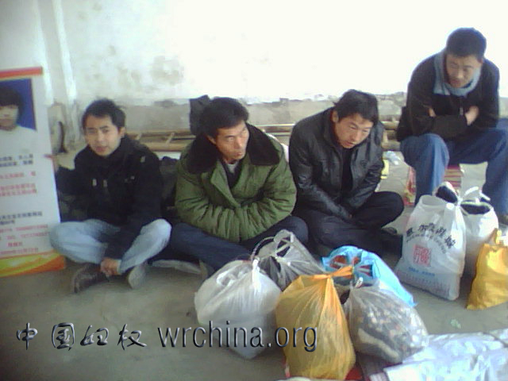
Because of a recent government crackdown following the Middle East uprisings, all of our humanitarian workers are facing pressure and scrutiny. The work itself is difficult and can be discouraging even without this added load, so we call on leaders in China to give more freedom to humanitarian workers as soon as possible.
Here volunteers were detained by police for participating in a campaign to rescue their sons and daughters.
We hope and pray that today, eyes will be opened to see trafficking as a real problem, not only for China, but for the surrounding nations.
What is Currently Being Done by China
In April 2009, Chinese security and police forces launched a campaign to reunite trafficked children with their families. During this nine-month anti-trafficking campaign, police rescued a total of 14,717 women and children. Police also arrested 17,528 suspects, including 19 who had a level A (most wanted) warrant against them. The authorities have been able to match thousands more through various methods, including DNA databases and social media. The Ministry of Public Security has begun to crack down on organized crime groups trafficking children to be used as beggars. A new online campaign to publish photographs of child beggars is helping to reunite families with children who have been kidnapped. Yet, so far our research has shown that very little to nothing is being done about the problem of child brides.
Neighboring Nations
Two-thirds of human trafficking cases uncovered by the Myanmar Police Force’s anti-trafficking units in 2009 involved women being trafficked into China for the purpose of forced marriage. Out of 155 human trafficking cases uncovered in 2009, 103 involved the forced marriage of girls and women, according to Myanmar Police Force figures. Most of the victims were lured by the promise of a relatively high-paying job in China but were then sold off to Chinese men, a spokesperson from the United Nations Inter-Agency Project (UNIAP) on Human Trafficking in the Greater Mekong Sub-Region told The Myanmar Times in 2010 (http://www.mmtimes.com/2010/news/512/n51206.html).“Most of the trafficked Myanmar women were sold to men in villages and poor communities in China, where Chinese men do not think of this practice as trafficking; instead they consider it as paying a dowry,” UNIAP national project coordinator Daw Ohnmar Ei Ei Chaw said.
“Men pay anywhere from RMB20,000 to RMB40,000 (US$2900 to $5800)—or even more—to a broker for a trafficked woman to be their wife, depending on the woman’s looks and age. They even have a wedding ceremony in their village. However, if this happens without the consent of the woman, it is clearly a trafficking case,” she said. While we recognize and support the recent police and security mobilization to rescue child beggars, it is clear that much more must be done to prevent the further trafficking of brides in China.
Our research also shows that the problem is growing. The majority of trafficking cases that affect China and surrounding nations are under-reported and are directly related to China’s overwhelmingly large number of men.
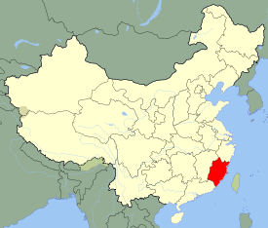
Case study: Putian: A Major Center of Child Bride Trafficking
Putian City is situated in the central coast of Fujian Province, population 306.97 million. The Putian area has a large number of trafficked women, many of whom lived the life of a child bride and cannot find their loved ones in distant areas for various reasons. Some were sold when too young, and after years of helplessness, the memory of their original homes has faded. From 2009 to 2011, during three separate campaigns, AGA and associated organizations helped reunite three former child brides from Beigao Town of Putian with their loved ones in faraway Guizhou province. They had almost no memories of their hometowns, only vaguely recalling a few words of their original dialect. The three victims were transported on trains through circuitous routes from Guizhou to Fujian. AGA volunteers with these scanty clues tried to match the womens’ memories to maps to find similar sounding towns and hamlets. Volunteers also turned to the media. After repeated efforts volunteers reunited these trafficking victims with their biological parents.
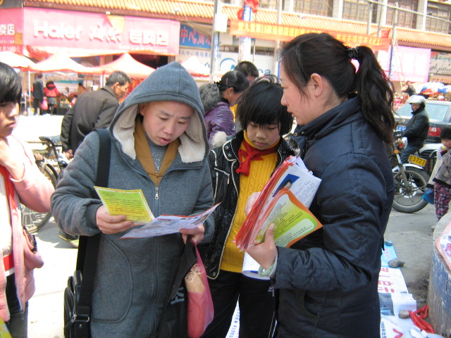
The AGA volunteer group started an educational campaign on March 27th, 2011, along the entire Putian coast. Volunteers received six requests for assistance from trafficking victims who were abducted at young ages. Within a short period of time, through local television and print media coverage, nearly 30 young women made contact with AGA volunteers to say that they had been stolen as children and sold as child brides. Everywhere that volunteers talked with local residents, the stories were the same. In Pinghai town, the average thirty year-old grew up with seven or eight siblings, even up to a dozen or more. Of these “siblings,” more than a quarter were bought and “adopted”— almost every household raised child brides. In the coastal fishing communities, the One-Child Policy has been largely ineffective because the villagers are not deterred by government fines.
Volunteers educate the public and distribute information.

Hundreds of Thousands of Trafficked Child Brides
Zhenping Village, Donghai Town, is 30 kilometers away from Putian city proper. Of the 900 households in this settlement with a population of 4,300, there are nearly a thousand trafficked child brides. A notorious case of a child bride being beaten to death occurred in 2003. The village was widely reported as a “Child Bride Village” in the media. According to a 2005 survey, the local primary school had 60 sixth grade students including 33 girls. 14 of them were child trafficking victims, accounting for 42.4% of the total number of girls. The fifth grade had 31 girls. 7 were trafficked, accounting for 22.6% of the total number of girl pupils.
However, the government has never conducted any investigation on the problem of trafficked child brides.
Conservative Estimate Using Beigao Town, Putian, as an Example
Using only the most conservative methods would still produce shockingly high numbers of child brides in the Putian region. In the 1980’s and 1990’s, rural Putian families had seven to eight children on average. In some families, the number could be even higher. Over a quarter of the children were bought. For example, Xiao Guangyan was kidnapped from Guizhou and raised in a household of eleven siblings, including three child brides. Peng Qinglan, another trafficking victim, had eight “siblings,” including two trafficked girls. Two of Wong Qinghua’s six “siblings” were bought. Wong Qinqin had many “brothers.” She was purchased as a child bride. In fact, eight children in these four families were trafficked girls bought to be raised as child brides. Five of them were eventually married to their “adopted brothers” inside the family.
In the 1980’s, during the most rampant period of its child trafficking trade, Beigao Town had a population of approximately 160,000. If average household size was ten (eight children plus two parents), there would have been 16,000 households. To use a conservative estimate, if one out of five households purchased a child bride, this gives a number of 3,200 child brides in Beigao Town alone.
To use Beigao, an average sized township, as a baseline, Licheng District, which includes six townships including Beigao, would have at least 19,200 child brides. There are six administrative districts in Putian City. Extrapolating from Licheng’s numbers would give an estimate of Putian’s child bride population at 120,000 (This number does not include trafficked boys). In other words, the most conservative estimate produces a number of 120,000 child brides trafficked to Putian in the 1980’s and 90’s.
The Pessimistic Estimate Using Beigao as an Example
As mentioned, the average Beigao family in the 1980’s raised eight children. If four of these children married outside of the family and one son married a child bride within the family, then a single family in the 80’s would have produced five families today. In other words, one of every five of Putian’s households today would have been formed from the union of a child bride. Excluding the possibility of multiple child brides, if an average family bought only one child bride, there would be 16,000 child brides in Beigao. Extrapolating with this number, Licheng District would have 96,000 child brides and the entire Putian region would have 576,000 child brides. In other words, the population of child brides in Putian region amounts to nearly 600,000.
Beigao is not the township with the highest concentration of fishing villages in Putian. It is not among the towns where the child bride trafficking problem is the most severe. We have used Beigao as the example for our calculations to obtain a more objective number. Coastal villages in Xiuyu District such as Litou and Pinghai had much higher proportions of trafficked women. In our campaigns in those areas, half the women we came into contact with had no memory of their childhood homes and origins, let alone their birth parents.
Based on the two estimates above, Putian’s child bride population ranges between 120,000 and 600,000. Even the lower estimate is shocking for a city the size of Putian. This number represents the suffering of 120,000 families and the sorrow of 120,000 girls and young women who have lost their precious freedom.

Twenty years after her abduction, with the help of AGA, Peng Qinglan (left) and Xiao Guangyan (right) finally found their biological parents.
Four Major Factors of Rampant Human Trafficking (specific to Fujian Province)
First, the coastal fishing villages are the traditional home base of many overseas Chinese. Economic conditions are generally far better here than in the Chinese interior. Families in this area could and still can afford fines for an “illegal” surplus population. Even government Family Planning Commission officials and their relatives purchase trafficked children with impunity. Local residents compete to have children. Marriage ages are generally rushed, with girls usually married at 17 and boys at 19. If not enough children are born, a family will buy children of both sexes. Trafficked boys are used to augment labor; girls are raised as child brides. The fishermen do not worry about the problem of children registration, especially after the end of rationing of clothing and basic foodstuffs. In 2010, Beigao residents had an average income of 19,068 yuan compared to the national average of 5,919 yuan. Governmental population policy fines are thus relatively affordable for the coastal fishermen who enjoy early prosperity. Even today, new families typically give birth to more than three children.
Second, a fishermen’s family serves as a basic economic unit. A fishing boat has to be served by the hard physical labor of at least five or six men, who are usually father and sons. If it is impossible to produce a sufficient number of boys, local families do not hesitate to buy children. The number of men in a family is taken as a sign of pride. As a result, for a long time men in these fishing villages have found it difficult to find wives, especially since local women tended and still tend to marry outside of the villages. Bride prices (to be paid to a woman’s family) are also extraordinarily high. The purchase of a trafficked young girl, even with the cost of rearing, is still more economical. Putian's economic structure, in addition to the rather unique single family fishing households, also includes the manufacturing of genuine or fake name brand footwear and clothing. There exists a large-scale demand for labor, which is common throughout the coastal areas of Fujian. Similarly, human trafficking has been prevalent in these areas. Additionally, the coastal region of Fujian has become a center of illegal drug trafficking. In fact, Beigao was named a focus point of the government’s anti-drug trafficking campaign. The Taiwanese fishing industry also has added more demand for cheap labor from the Mainland, absorbing large numbers of local young males and giving additional incentive to local families to buy boys. Correspondingly, more girls are trafficked into the region to become child brides to accomodate the gender imbalance.
Third, the deep-rooted discrimination of girls and women persists. Many parents will not disclose to a boy they have bought that he was “adopted.” However, it is different for girls. To dispel their psychological reluctance to marry men who were reared as their “brothers,” the family will easily disclose the girls’ origins as trafficked children. Local families almost uniformly inform trafficked girls that they are from Changle, another Fujian city. The neighboring city of Changle has become an important transfer market for trafficked populations. Police have cracked a number of human trafficking rings that traded in Changle. These criminal groups are usually organized by families. The kidnapping and transport of children is thus streamlined and comprehensive. Chongqing government reported on August 16, 2010 that it arrested, during a rescue operation in Changle, 17 suspects, all members of an extended family, who kidnapped 15 children ranging from ages 2 to 7.
Fourth, the local government and police acquiesce help to condone the purchasing of trafficking victims by local families. Authorities know that almost every household has a child bride, but have never investigated the increase of the unregistered population or the sudden appearances of children in a family. Many of the purchasers are friends and relatives of the authorities. Similar situations exist in larger areas of Fujian province. Protests to local authorities are unlikely to produce any result other than violent retaliation by human traffickers.
Conclusions Regarding Rampant Human Trafficking in Fujian Province and Elsewhere
An official of the Putian Welfare Department, when talking about the case of the child bride who was beaten to death, said that the government was aware of trafficked child brides in Pingyang village, but considered it outside of their jurisdiction. He said that if a girl was born outside of the legal quota, the Population Planning Bureau would be responsible. However, human trafficking is entirely the police’s concern. If the child brides are not registered with the government, the welfare departments have no methods to register them, since laws on adoption do not apply. The official considered child brides in remote areas to be normal. He did not think reporters should have investigated this problem, asking “Would you help them find wives?”
Putian’s rapid economic rise in the last few decades has progressed concurrently with the expanding child bride trafficking problem. As families have witnessed the unhappy results of child bride unions, very recently the purchase of young girls solely for the purpose of becoming brides has abated somewhat. However, nationally the problem has become more serious. Since 2005, Northern provinces like Shaanxi, Shanxi, Henan, and Shandong have seen a sharp increase in the number of missing girls. In Heilongjiang Province in May 2007, nine girls went missing at the same time. Four were eventually rescued by the Heilongjiang police, but the rest remain missing. In October 2008, four students of the Commercial School in Jilin City went missing. The local police department would not take the case until over a month later in order to manipulate crime statistics in the jurisdiction.
The number and price of trafficked girls have overtaken the number of trafficked boys as a result of the severe gender imbalance produced by the One-Child Policy in poor rural areas. For the foreseeable future, the trafficking of girls and young women will only increase due to the large and growing demand for brides in the countryside.

http://www.geerga.com/node/179
http://www.xiancn.com/gb/news/2005-12/23/content_748098.htm
Guizhou governmental press, Haixia Dushibao, June 26, 2006
Putian City website.
Chinese National Statistical Bureau
Haixia Dushibao, June 26, 2006
http://www.xbpf.gov.cn/platform/news_view.asp?newsid=5013
http://www.xiancn.com/gb/news/2005-12/23/content_748098.htm
Urban Evening Paper, Nov. 5, 2008

